Asset Allocation in Robo-Advising:

An overview of portfolio weighting schemes

By: Chenghao Zhu, Yuxuan Zhou, Haoyang Shang, Yufei Wang, Zhengwu Zhu

**Abstract**

In this academic paper project, we take a close look at the asset allocation methods that robo-advising may use based on 'Robo Advisors: quantitative methods inside the robots' by Mikhail Beketov, Kevin Lehmann, and Manuel Wittke. Its study shows majority of the robo advisors are still using the Modern Portfolio Theory in terms of modification and augments instead of developing new methods. Later in this paper, we tested the efficiency of three different portfolio weighting schemes used in Robo Advising: mean-variance analysis, full-scale optimization, and risk parity, using empirical methodology. We concluded that the full-scale optimization method with kinked utility function gains no advantage, while the same method with the S-shaped method can outperform the traditional mean-variance method. Meanwhile, despite similar performance with mean-variance by risk parity most of the time, it can make a change during worse scenarios.

**Part I: Introduction**

Robot Advisors (RAs) is an important force for change in the current asset and wealth management industry. 2022 The annual asset management scale is US$1.16 trillion and will maintain a compound growth rate of 14.45%. It is expected that the total asset management scale will reach US$1.99 trillion in 2026. This growth is driven by the rise of a new generation of consumers, RAs’ advantages over traditional consultants, and rapid expansion in the Asian market. There is a wealth of information about RA systems, but still little is known about the core portfolio optimization and asset allocation methods applied within these systems. There is only a few comprehensive analysis of the methods used in RAs, their occurrences in these systems, the respective volumes of assets under management (AuM), and the future methodological prospects of the Ras.

By studying the article 'Robo Advisors: Quantitative Methods Inside the robots' by Mikhail Beketov, Kevin Lehmann, and Manuel Wittke, we can gain some insights. This article's research involves the analysis of 219 global Robo Advisors (RAs). By analyzing the official websites of these 219 RAs worldwide, information about their asset allocation and portfolio optimization strategies was collected. The dataset included RAs from 28 countries, with 30% of the companies located in the USA, 20% in Germany, 14% in the UK, 9% in Switzerland, and the remaining 27% in other countries. The RAs in the dataset were founded between 1997 and 2017, with the average founding year being 2014 (the most frequent years are: 2016—48%, 2015—16%, 2017—15%, and 2014— 14%). The AuM volumes of the analyzed RAs ranged from 1 to 93,000 million USD, with the average and median values being 3,739 and 85 million USD, respectively. It also comes up with the main building blocks of Robo Advisors.



In this paper, the authors compiled a comprehensive table listing all methods mentioned on the web pages of each Robo Advisor (RA), varying from one to five terms per RA, to analyze their usage frequency. This table encapsulated both specific and general methodologies, from well-defined ones like “Modern Portfolio Theory” and “Risk Parity” to more ambiguous terms such as “Sample Portfolio” and “Constant Portfolio Weights.” Due to the data's vague nature, they conducted two separate analyses: first, identifying the primary methodological framework of each RA and then counting the occurrences of all methods, irrespective of their clarity or specificity. These methods were visualized using a word-cloud graph, with font size proportional to frequency, to depict the overall methodological landscape of RAs. Additionally, they gathered data on Assets under Management (AuM) linked to these methods, mainly from the Investment Adviser Public Disclosure website for U.S. companies and the Techfluence database for others, to estimate the AuM managed by different methods. The paper also delves into a detailed analysis of 28 selected RAs, including those identified as top RAs by BI Intelligence and most relevant to German investors by the Capital Journal, to understand their complete methodological frameworks from asset selection to performance monitoring.

The analyses of 219 Ras showed that information about the asset allocation methods is only available for 73 systems. The other systems either do not provide such information or do not use any asset allocation methods Therefore, they considered only these 73 RAs for all of the analyses described here. In these 73 systems, we have found the names of 31 various methods. Analysis of the main methodological frameworks showed that the most frequently applied/mentioned framework is Modern Portfolio Theory followed by Sample Portfolios and Constant Portfolio Weights. Among these three terms, only the first can truly be called a quantitative methodological framework, whereas the other two are general definitions provided on the companies pages, which may include various methods unknown to us. Their analyses of the correspondence between the methods’ occurrence and the respective AuMs, as expected, showed that Modern Portfolio Theory has the highest AuM volume.A table with black text

The analysis revealed two interesting trends. First, most current Robo Advisors (RAs) use Modern Portfolio Theory, and importantly, they tend to improve and augment this framework rather than applying and developing entirely new methods. Second, companies using relatively sophisticated methods attract higher Assets under Management (AuM) volumes despite these methods being applied less frequently than simpler and more generally defined methods.

Finally, the author mentioned certain asset allocation schemes that are suitable for RAs and offer both promising performance as well as a certain marketing appeal, such as Risk Parity (Roncalli2013), Full-Scale Optimization (Cremers et al. 2005; Adler and Kritzman 2007), Scenario Optimization (Adler and Kritzman 2007; Calafiore 2013), and Risk Parity with Skewness Risk (Bruder et al. 2016).

In this project, we will test the efficacy of selected portfolio weighting schemes and the difference between each optimization method, whether they would agree with the finding and the extended suggestion of this paper, helping us to gain insights into the asset allocation in robo-advising.

**Part II: Mean-Variance Optimization**

Instead of overly pursuing the maximum expected return as such would ignore the principle of diversification, in his paper “Portfolio Selection” (1952), Markowitz proposed that investors should choose a portfolio that has the highest expected return for a given level of variance (called E-V maxim). He also identified an “efficient frontier”, in dimensions of expected return and standard deviation, by the continuum of portfolios or combination of securities that maximized return with given levels of risk. According to Markowitz’s E-V maxim, one should choose a portfolio located along this frontier.

This approach would have two assumptions to sufficiently maximize the utility of expected return: 1) portfolio returns are normally distributed 2) investors have quadratic utility defined as follows:

where equals portfolio expected return, equals risk aversion, and equals portfolio variance. However, the reality might not be aligned with these assumptions. No asset return is perfectly normally distributed and the quadratic utility function does not necessarily capture the investor preference and behavior pattern: at a certain point, it indicates investors would prefer less wealth over more wealth.

In contrast, a kinked utility function is more likely to describe one’s attitude toward risk. It defines utility as a log-wealth function above the threshold return and a steeper function below the threshold return. It takes the form of the following:

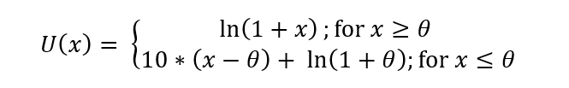

, where is the portfolio return, and is the return threshold.

In the study of Kahemann and Tversky(1979), they found that people focus on return more than wealth levels and they are risk reserve in the domain of gain and risk-seeking in the domain of losses. Investors will choose certain gain over an uncertain outcome with higher return and will choose uncertain outcome with lower gain over a certain loss. Such behavior is captured by the S-shaped value function as follows:

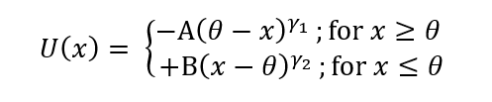

subject to

Where is the portfolio’s return and are the parameters that control the degree of loss aversion and the curvature of the function for outcomes above and below the return threshold .

The graph looks like this:

Due to previous assumptions that might not be satisfied by the actual scenario in reality, mean-variance analysis, suggested by the paper, always yields a solution that is an approximation to the true in-sample utility-maximizing portfolio. Thus, it suffers approximation error and estimation error as the approximation error could be either negligible or overwhelming and in-sample data (means, variances) might not be precisely the same out-of-sample.

**Part III: Full-scale Optimization using Two Utility Functions**

Besides Using the power utility function and quadratic function to describe investors’ attitude towards risk, we introduce two other more realistic function according to different situation: kinked utility function and risk changing utility function, both described in part II.

Due to oversimplified assumptions about the distribution of market returns and investor preferences. Precise portfolio optimization solutions cannot be provided in some cases. In comparison, the function introduced above is more realistic. Furthermore, we will introduce the full-scale optimism analysis (combined with the two utility functions above).

Contrast to mean-variance analysis: in the full-scale optimism analysis, we shift the weight in each period until we get the maximum expectation utility. This method can eliminate the approximation error but cannot still eliminate the estimation error. Another advantage of using full-scale optimism is that it can apply to both empirical distributions, theoretical distributions, or combinations.

**Part IV: Classic and Modified Risk Parity Weights**

The last portfolio optimizing strategy that we want to explore is Risk Parity. Risk parity seeks to allocate capital across various assets in a way that equalizes the risk contribution of each asset to the overall portfolio. This strategy differs from mean-variance analysis in the sense that it focuses solely on the risk component. The primary concern is balancing the portfolio's risk contributions, not optimizing returns. The paper "A Modified Risk Parity Method for Asset Allocation" by Akhilesh Maewal and Joel R. Bock proposes an innovative approach to the risk parity method. While classical risk parity methods are based exclusively on volatility, the new solution (Modified Risk Parity) considers both historical returns and their variance in the construction of an optimal, diversified investment portfolio. The modification is based upon a single scalar parameter which can be tuned to tailor the allocation for desired expected risk and/or return.

Classic Risk Parity Weights:

To calculate classic risk parity weights, we first sum up all the inverse volatilities of the assets in the portfolio. Then, for each asset, divide its inverse volatility (standard deviation) by the total sum of inverse volatilities. This gives us the proportion of each asset's risk in the total portfolio risk.

The weight of asset *i* in the portfolio, , is calculated using the following equation:

where is the standard deviation of asset *i* and *n* is the total number of assets in the portfolio.

In the paper, classic risk parity weights are written as the following:

Where is the variance of asset *i*, and *k* is a constant determined by the condition that the sum of *wi*​ equals 1.

Modified Risk Parity Weights:

In the paper, modified risk parity weights have the form:

Where is the return modified standard deviation, is the standard deviation of the daily returns of asset *i*, is the annual return of asset *i*, and *α* is the return exponent.

In the next part of the project, we tested the classic risk parity weights against the modified risk parity weights to calculate portfolio returns and Sharpe Ratios, to test its effectiveness.

**Part V: Empirical Findings**

**Methodology:**

We did our empirical analyses on a 10-year-range monthly data on mutual funds from January 2013 to December 2022. We use this sample because, according to Alexiev (2004), Davies et al. (2003), mutual funds and hedge funds tend to display significantly non-normal higher moments. As the original paper uses data from 1994-2003, we think it doesn’t make sense to do our empirical research using data from such a distant period, we did our research on the most recent data set, and we will compare our results from the original one.

We split our analyses into two parts, one about the comparison between full-scale optimization and mean-variance, and another about the comparison between risk parity method and mean-variance. For the full-scale optimization part, we consider the same four utility functions as Adler and Kritzman (2006), the kinked utility function with the kink set at -1 and -5 percent respectively, and the S-shaped utility function with the inflection point set at 0 and 0.5 percent. These utility functions with different parameters can serve as a good proxy for investors in the real world with different risk preferences and backgrounds, which is an important part of robo-advisor.

For both parts, we use the same logic, divide analyses into in-sample ones and out-of-sample ones. To achieve this, we split our data set into four parts, each one with a 2.5-year range, so that we can do in-sample and out-of-sample for 3 times. For the in-sample part, we come up with the optimal portfolio by maximizing utility using a full-scale optimization algorithm or calculating the risk parity weights. Then we seek to find the portfolio with the same expected returns on the mean-variance efficient frontier, both short sales allowed. Theoretically, we will find the MV in-sample result with lower standard deviation and higher Sharpe ratio, while the full-scale one with higher utility.

After coming up with the corresponding weights, we can move on to the out-sample-part. We use the optimal weights calculated above to construct portfolios for the next non-overlapping period and compare the performance between the mean-variance method and full-scale or risk parity.

**Empirical results:**

Figure 1 shows the mean-variance efficient frontier for the entire period we use:

Figure 1 Efficient frontier

Table 1 illustrates specifically for the logic of full-scale optimization for the kinked utility function, with the similar one for S-shaped utility function, which is a corresponding one for table 2, the original table.

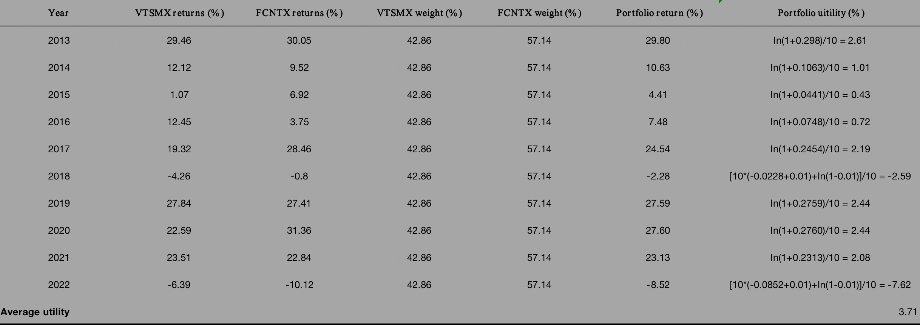

Table 1 Full-scale optimization with kinked utility function

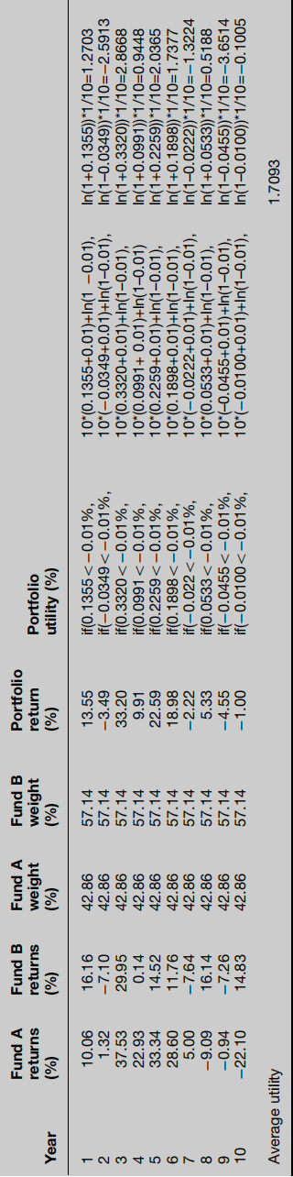

Table 2 Original full-scale optimization with kinked utility function

Tables 3,4, and 5 show the result of 3 different analyses for the comparison between full-scale optimization and mean-variance, with in-sample and out-of-sample results both included, each covering a range of 5 years. Tables 6 and 7 will cover the similar table from the academic paper we use.

Table 3 Full-scale comparison results from 2013.01 - 2017.12

Table 4 Full-scale comparison results from 2015.07 - 2020.06

Table 5 Full-scale comparison results from 2018.01 - 2022.12

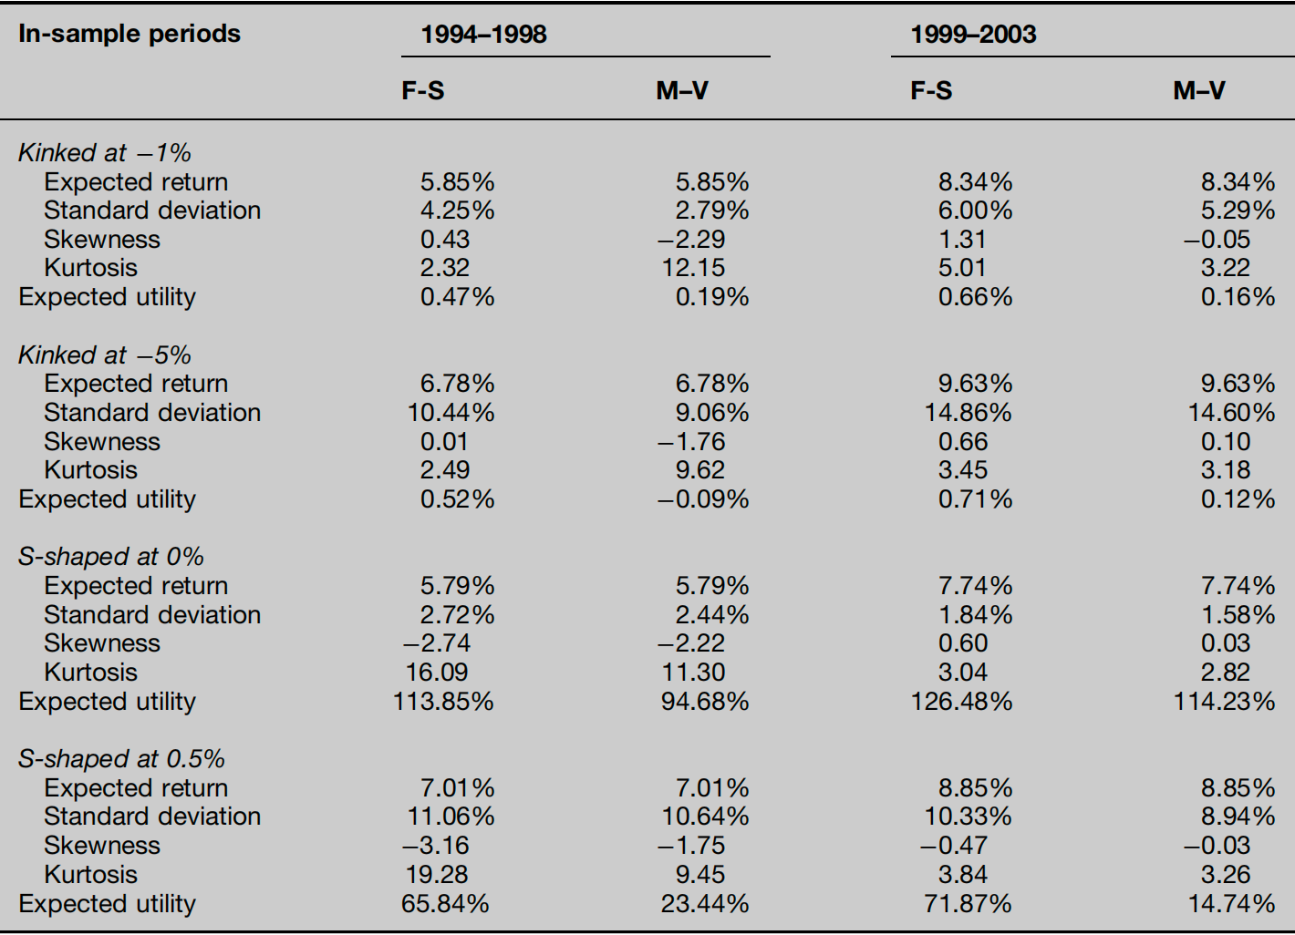

Table 6 In-sample result from original paper

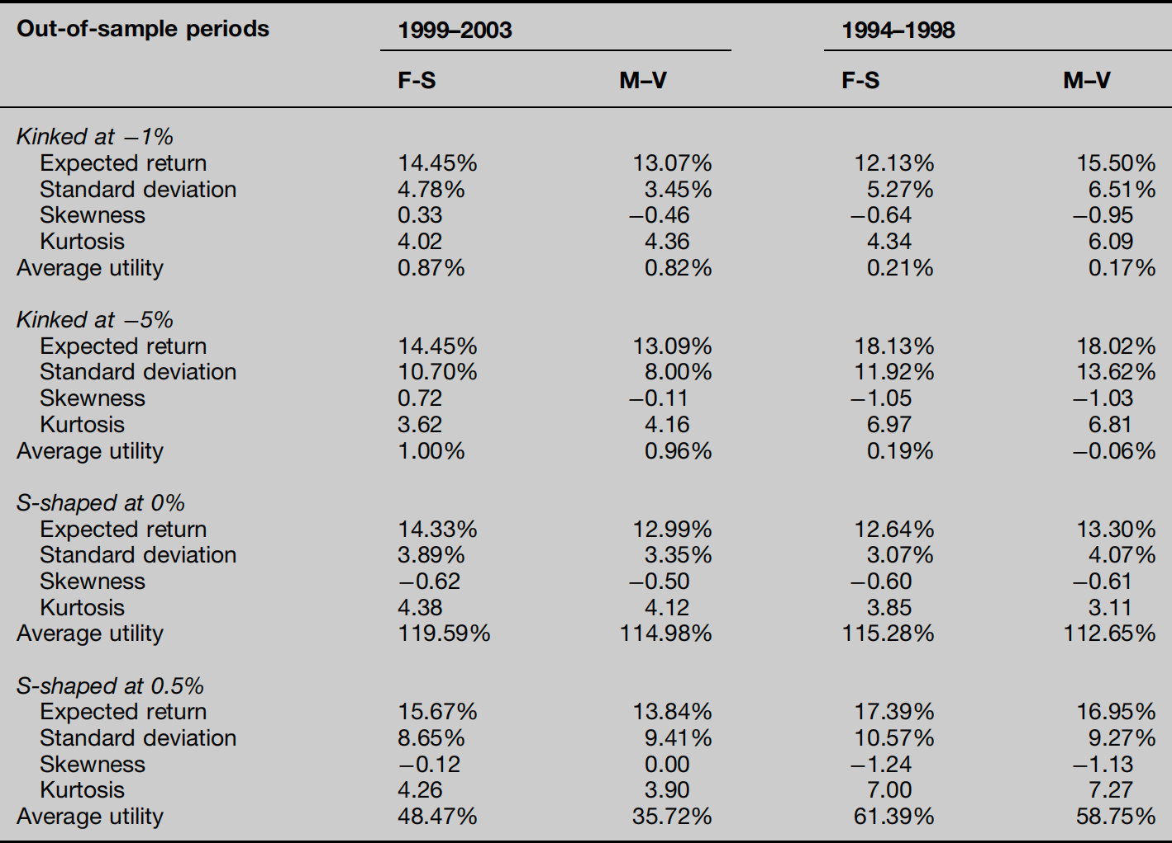

Table 7 Out-of-sample result from original paper

The results in these 3 tables demonstrate that for the in-sample performance, with the same expected return, mean-variance efficient portfolios share a higher Sharpe ratio, while full-scale optimization portfolios ensure higher expected utility as we assume. However, for the out-of-sample performance, different utility functions show completely divergent results. For both kinked utility functions, panel 3 and 4 in each column reveal that for most of the time, M-V outperforms F-S as the former one not only has a higher Sharpe ratio but also exceed in expected utility. When it comes to both S-shaped utility functions, F-S beats M-V in all 3 periods for both the Sharpe ratio and expected utility. Surprisingly, even for the out-of-sample analysis in the COVID-19 period, full-scale optimization with S-shaped utility function gets a positive annual return, which performs way better than the mean-variance method.

Table 8 summarizes the frequency of time when full-scale optimization outperforms mean-variance in utility for different out-of-sample periods, which can better corroborate with our view that the full-scale optimization method with S-shaped utility function performs well. Table 9 is the corresponding table in the original paper.

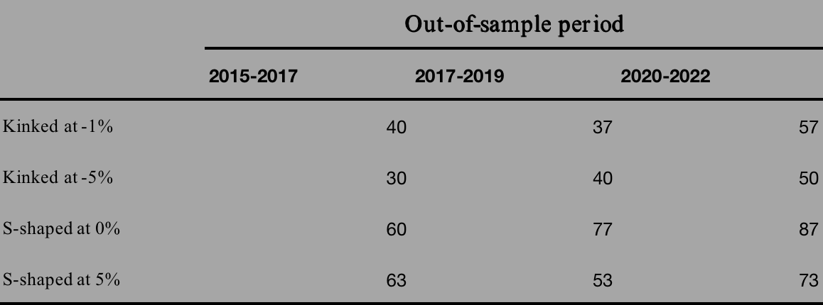

Table 8 Frequency (%) of F-S utility > M-V utility

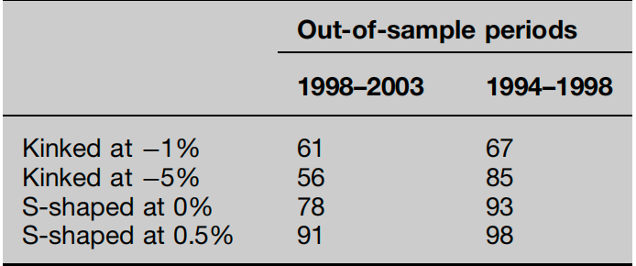

Table 9 Frequency (%) from original paper

Table 10,11, and 12 demonstrate the results of comparison between risk parity method and mean-variance method, with the methodology same as before.

Table 10 Risk parity comparison results from 2013.01 - 2017.12

Table 11 Risk parity comparison results from 2015.07 - 2020.06

Table 12 Risk parity comparison results from 2015.07 - 2020.06

The in-sample results seem to show the better performance of the mean-variance efficient portfolio as with expected return equal, only standard deviation and Sharpe ratio are involved. However, the higher standard deviations of the risk parity portfolios might result from upside deviations, given the asymmetry of the return distributions.

Regarding the out-of-sample analysis, the results seem to vary a lot. with Table 4 showing a better performance of M-V, table 5 revealing the similarity between the Sharpe ratio, and Table 6, the period for COVID-19, demonstrating a positive annual return for both modified and unmodified R-P, while a predictable bad performance of M-V. The results above demonstrate that we cannot tell which is a better strategy between risk parity and mean-variance efficient portfolio, but when it comes to poor scenarios such as turbulence across the entire financial market, the risk parity method can indeed somehow control the risk and offer a cushion for investors.

**Part VI: Conclusion**

From the result of our empirical methodology analysis, using in-sample and out-of-sample and employing different utility functions for optimization purposes, we concluded that a full-scale optimization method with a kinked utility function gains no advantage, while the same method with an S-shaped method can outperform traditional mean-variance method. Meanwhile, despite similar performance with mean-variance by risk parity most of the time, it can make a change during worse scenarios, which offers cushions for investors under the riskier scenarios and volatile financial market.

The paper 'Robo Advisors: Quantitative Methods Inside the Robots' reveals that the majority of current RAs use modified or augmented modern portfolio theory, and the author comes up with some alternative asset allocation methods that may make a better performance. Our analysis seems to align with such a view that mean-variance performs badly during a poor financial environment, while some other methods may fix this. Specifically, our new insight into the paper about full-scale optimization is that we consider the risk parity method, and we also find that mean-variance performs poorly during a volatile financial market, while full-scale optimization with S-shaped function and risk parity method can be a better choice.

**Citation**

1. Beketov, Mikhail, et al. “Robo advisors: Quantitative methods inside the Robots.” *Journal of Asset Management*, vol. 19, no. 6, 2018, pp. 363–370, https://doi.org/10.1057/s41260-018-0092-9.
2. Adler, Timothy, and Mark Kritzman. “Mean–variance versus full-scale optimisation: In and out of sample.” *Journal of Asset Management*, vol. 7, no. 5, 2006, pp. 302–311, https://doi.org/10.1057/palgrave.jam.2250042.
3. Maewal, Akhilesh, and Joel R Bock. “A modified risk parity method for asset allocation.” *SSRN Electronic Journal*, 2018, https://doi.org/10.2139/ssrn.3272080.
4. Markowitz, Harry Max. *Portfolio Selection: Efficient Diversification of Investment*. Blackwell, 1991.